**Name: ______________________________________ Date: __________ Period: _____**

**Lab: Safe from the Quake**

**It must be pretty scary to be in a house when an earthquake hits. First, the light fixture on the ceiling starts to move; then, drinking glasses on the shelf rattle and clank. Should you get in a doorway for protection, run outside, or hope it’s going to be another “little one”?**

**Engineers have invented ways to make structures safer during earthquakes. Your task is to invent a seismic-safe tower. The tower must be at least 60cm high and use only the materials your teacher gives you. You may design and use other materials to make a base for the tower to set on.**

**The total mass of your tower and base can be no more than 3kg. Work with your classmates and teacher to plan how to simulate earthquake waves to test your tower. The test must be exactly the same for all towers.**

**MATERIALS FOR THE EXPERIMENT: (for each group)**

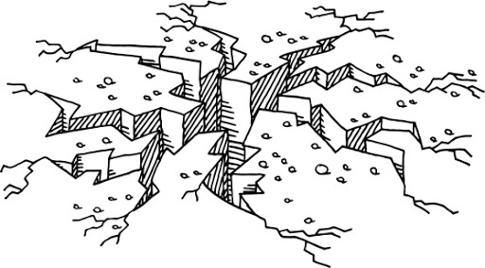**24 Plastic Drinking Straws**

**50 cm of masking tape**

**pan balance**

**scissors**

**40x40cm cardboard**

**INVESTIGATION:**

1. **Draw a design your tower and be sure to include measurements.**
2. **Draw a design for the base of your tower, including measurements. Make a list of the materials you need. Get your plan for the base approved by your teacher before you begin building.**
3. **Build our tower and its base.**
4. **Attach your tower and base to the cardboard. You may be allowed to test your tower and base on the seismic tester. After the test, plan and make improvements.**
5. **After you’ve improved your tower, submit your final tower to be tested again. Take notes on each tower that is tested in your class. Observe which design features help towers survive the seismic test.**
6. **Write a summary of the design features that seem to be the most important in helping towers survive the seismic test. Explain why those design features work. Write a description of how the seismic tester was like and unlike a real earthquake.**

**_______________________________________________________________________________________________________________________________________________________________________________________________________________________________________________________________________________________________________________________________________________________________________________________________________________________________________________________________________________________________________________________________________________________________________________________________________________________________________________________________________________________________________________________________________________________________________________________________________________________________________________________________________________________________________________________________________________________________________________________________________________________________________________________________________________________________________________________________________________________________________________________________________________________________________________________________________________________________________________________________________________________________________________________________________________________________________________________________________________________________________________________________________________________________________________________________________________________________________________________________________________________________________________________________________________________________________________________________________________________________________________**